***Unfolding Graphs :***

* *RNN unfolding, or “unrolling,”*is the process of expanding the recurrent structure over time steps.
* During unfolding, each step of the sequence is represented as a separate layer in a series, illustrating how information flows across each time step.
* This enables backpropagation through time (BPTT), where errors are propagated across steps to adjust weights, allowing the RNN to learn sequential dependencies effectively.

**Diagram :**

**Refer in Book !!**

**Key Concepts of Unfolding in RNN**

**1. Recurrent Graph:**

An RNN has a cyclic graph representing the relationship between the current hidden state () and the previous hidden state (). The computation at time depends on the input () and the hidden state .

**2. Unfolding the Graph:**

To perform computations, the recurrent graph is "unfolded" into a feedforward graph across the sequence's time steps. This creates a sequence of nodes where each node represents the computation at a specific time step.

**3. Unfolded RNN:**

For a sequence of length , the unfolded graph explicitly represents time steps: 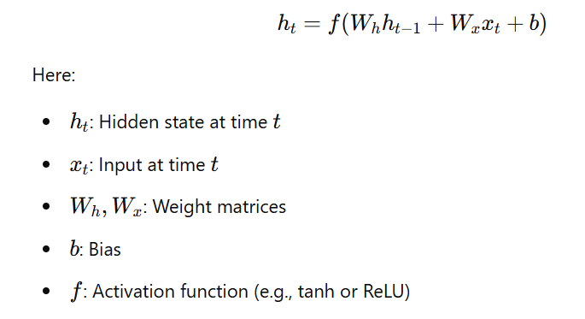

**Illustration :**

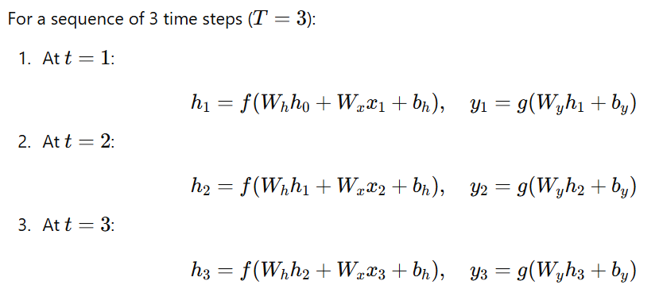

**Training via Backpropagation Through Time (BPTT):**

Unfolding is necessary for computing the gradients of the loss with respect to weights across all time steps. During BPTT, the gradients are backpropagated through the unfolded graph to update the weights.

**Advantages of Unfolding in RNNs:**

1. **Models Sequences:** Helps RNNs understand how data changes over time.
2. **Training Possible:** Enables the backpropagation process to adjust weights and learn from sequences.
3. **Efficient Parameters:** Uses the same weights for all steps, saving memory and improving consistency.

**Disadvantages of Unfolding in RNNs:**

1. **Hard to Learn Long Patterns:** RNNs often struggle to remember information from far back in the sequence.
2. **Computationally Heavy:** Requires more memory and time, especially for long sequences.
3. **Vanishing/Exploding Gradients:** Gradients can shrink or grow too much, making training unstable.

**Applications :**

* Natural Language Processing (e.g., text generation, sentiment analysis).
* Time Series Analysis (e.g., stock prediction).
* Sequence-to-Sequence Tasks (e.g., machine translation).